Password Reset via Self-Service Password Reset

Objective
Allow employees to reset their own password autonomously via the Contoso self-service tool, without contacting IT.

Responsibility
The employee themselves performs this process. Available 24/7.

Step-by-Step
- Access: https://passwordreset.contoso.com/
- Enter the username (usuario@na.contoso.com) and the Captcha.
- Obtain the verification code via Microsoft Authenticator.
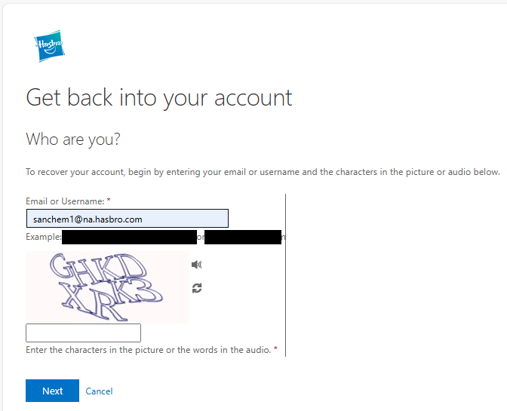

- Set the new password following the standard: uppercase and lowercase letters, numbers, and special characters, with more than 8 characters:
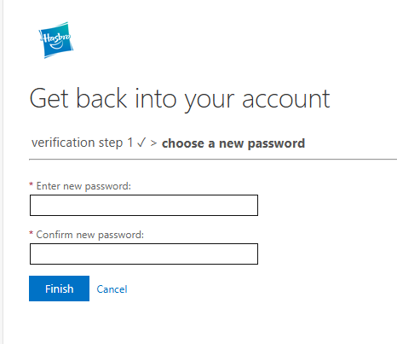
- Click "Finish". Password changed successfully!

Version History
IT Team | 1.0 | 28/07/2025 | Creation
Lucas Souza | — | Jun/2026 | Process separation
Lucas Souza | — | Jun/2026 | Document standardization

